MACARTHUR JROTC NEWSLETTER VOLUME 4
December 2020
Article and photos by Cadet Captain Jeslyn Hanza and Cadet Staff Sergeant Addy Rosado
Welcome back from Thanksgiving break cadets. The Highlander Battalion was very busy in the month of November. We held a non-perishable goods drive, participated in the District Wide Drill Meet, we assisted Eisenhower with cleaning up Cameron Stadium after their football game, cleaned Cameron Stadium after our team's last game of the season, participated in a virtual 5K with The University of central Oklahoma, cleaned the street adopted by JROTC, participated in the Veterans Day ceremony and parade. We donated over 430 pounds of food to the Armed Services YMCA. Delta Company brought 233.36 pounds of food, winning them a pizza party! We placed 2nd overall at the Drill Meet and brought home lots of trophies and medals. We performed our last stadium clean up for the year. The Highlander Battalion has adopted a section of Gore Blvd starting at the Hop 7 Sack at East 45th street and Gore Blvd to the EZ-GO at Flower Mound and Gore Blvd. Congratulations to the Cadet of The Quarter winners; LET 1 winner is Cadet PFC Riha and the LET 2-4 winner is SGT Lela’au Ueligatone. Thank you to everyone who participated in the events this month!
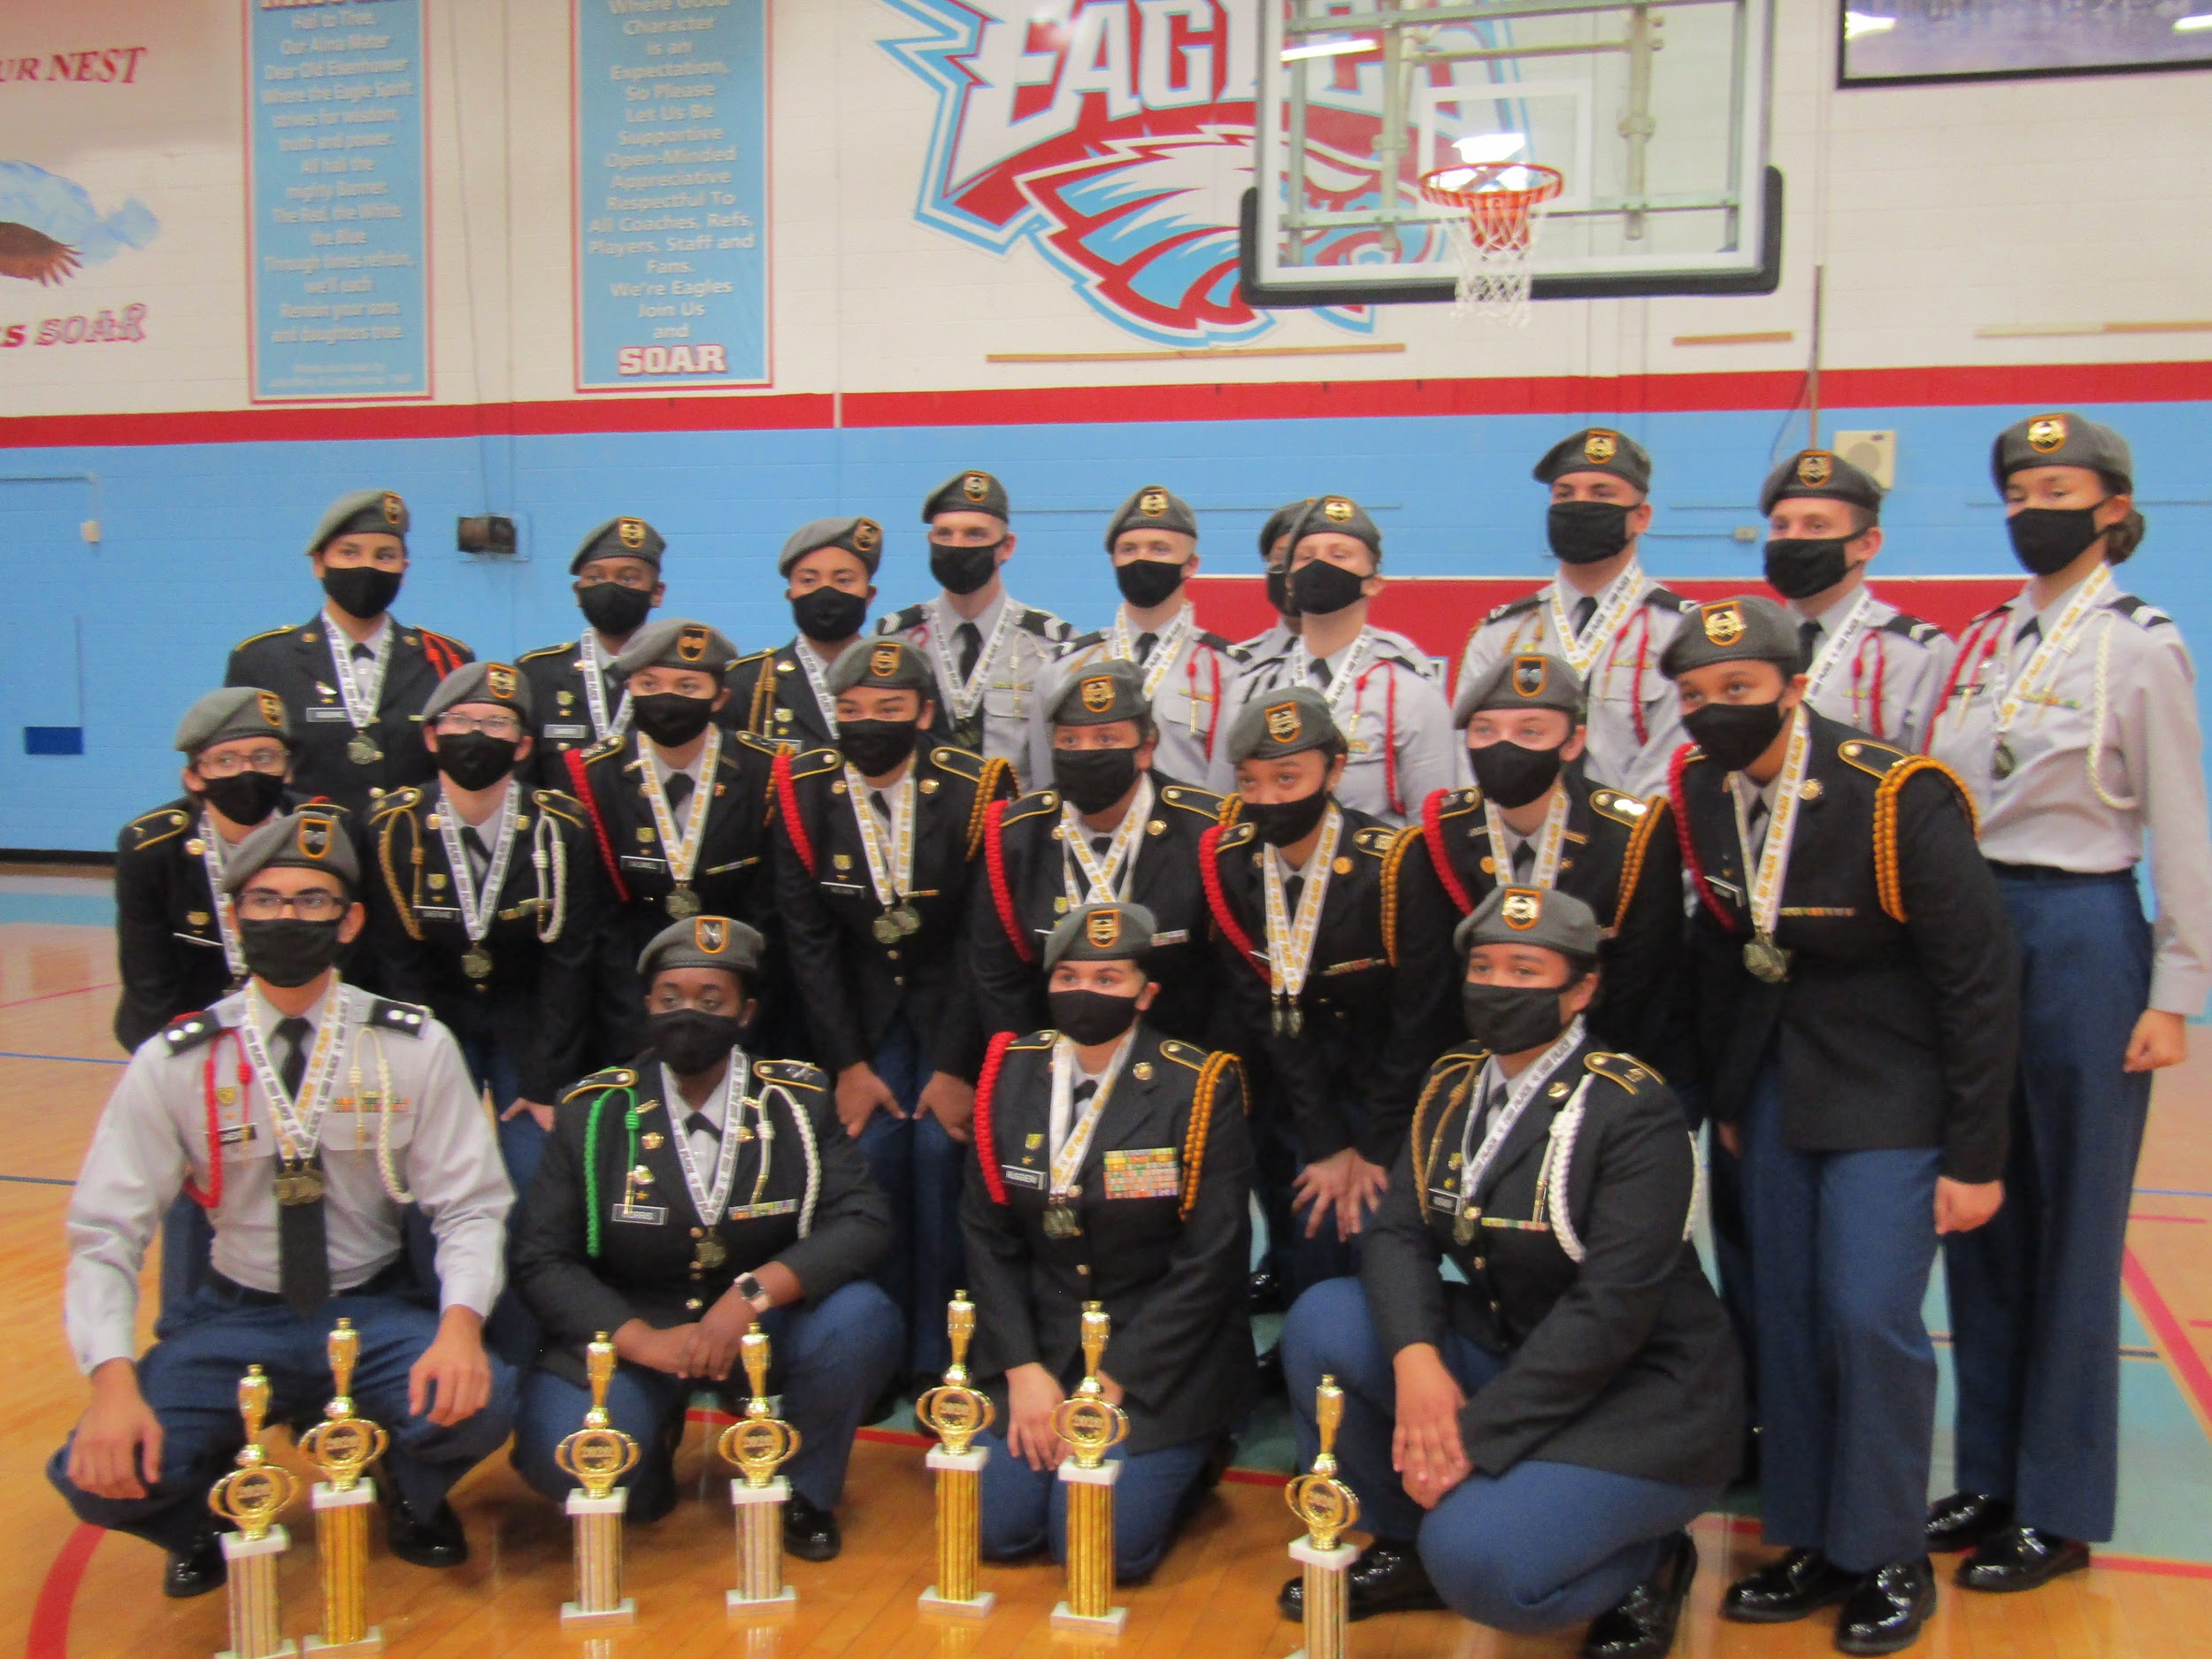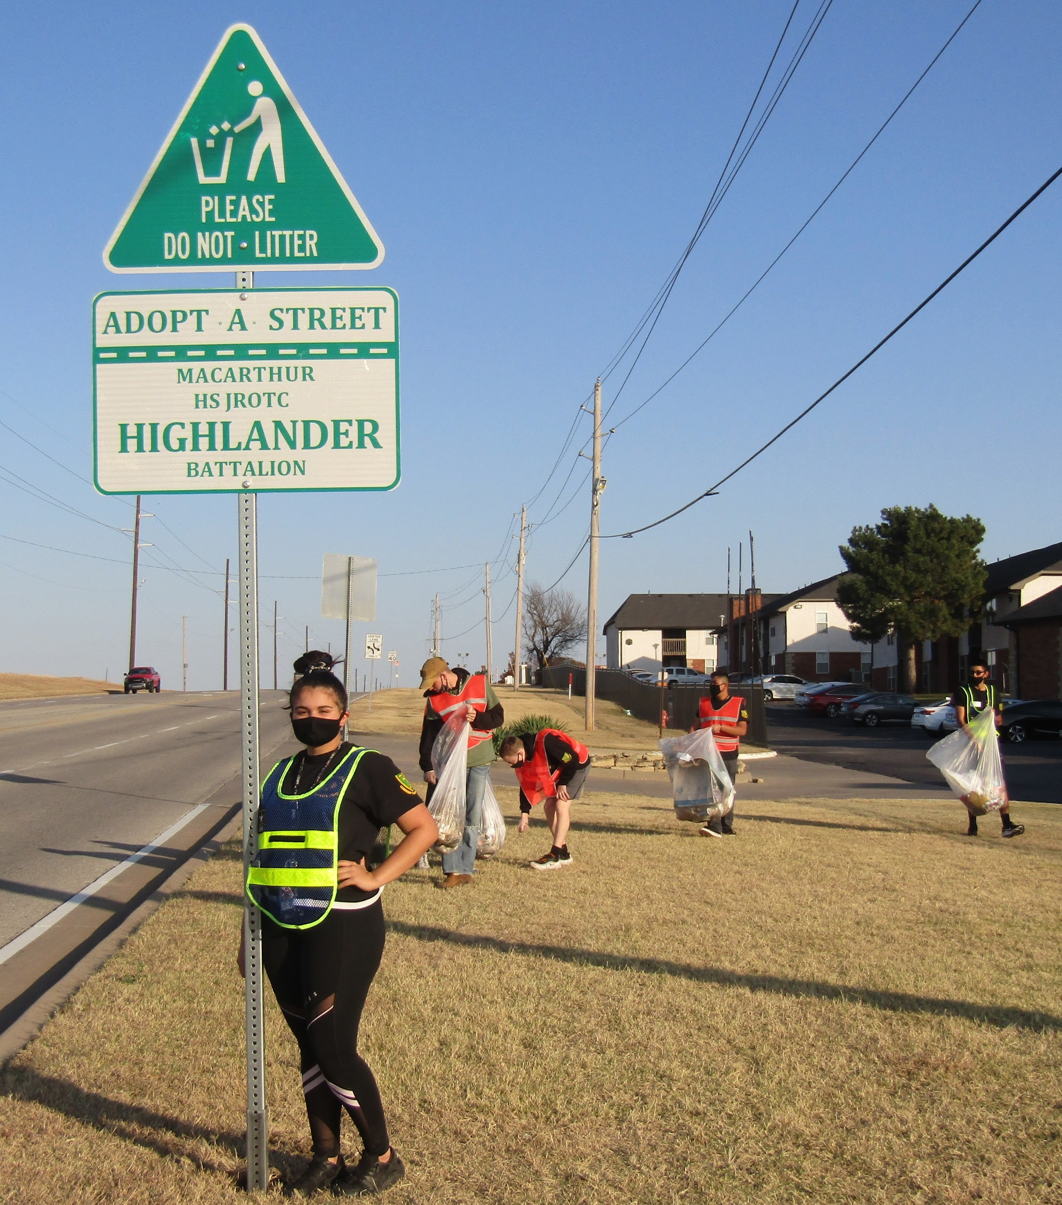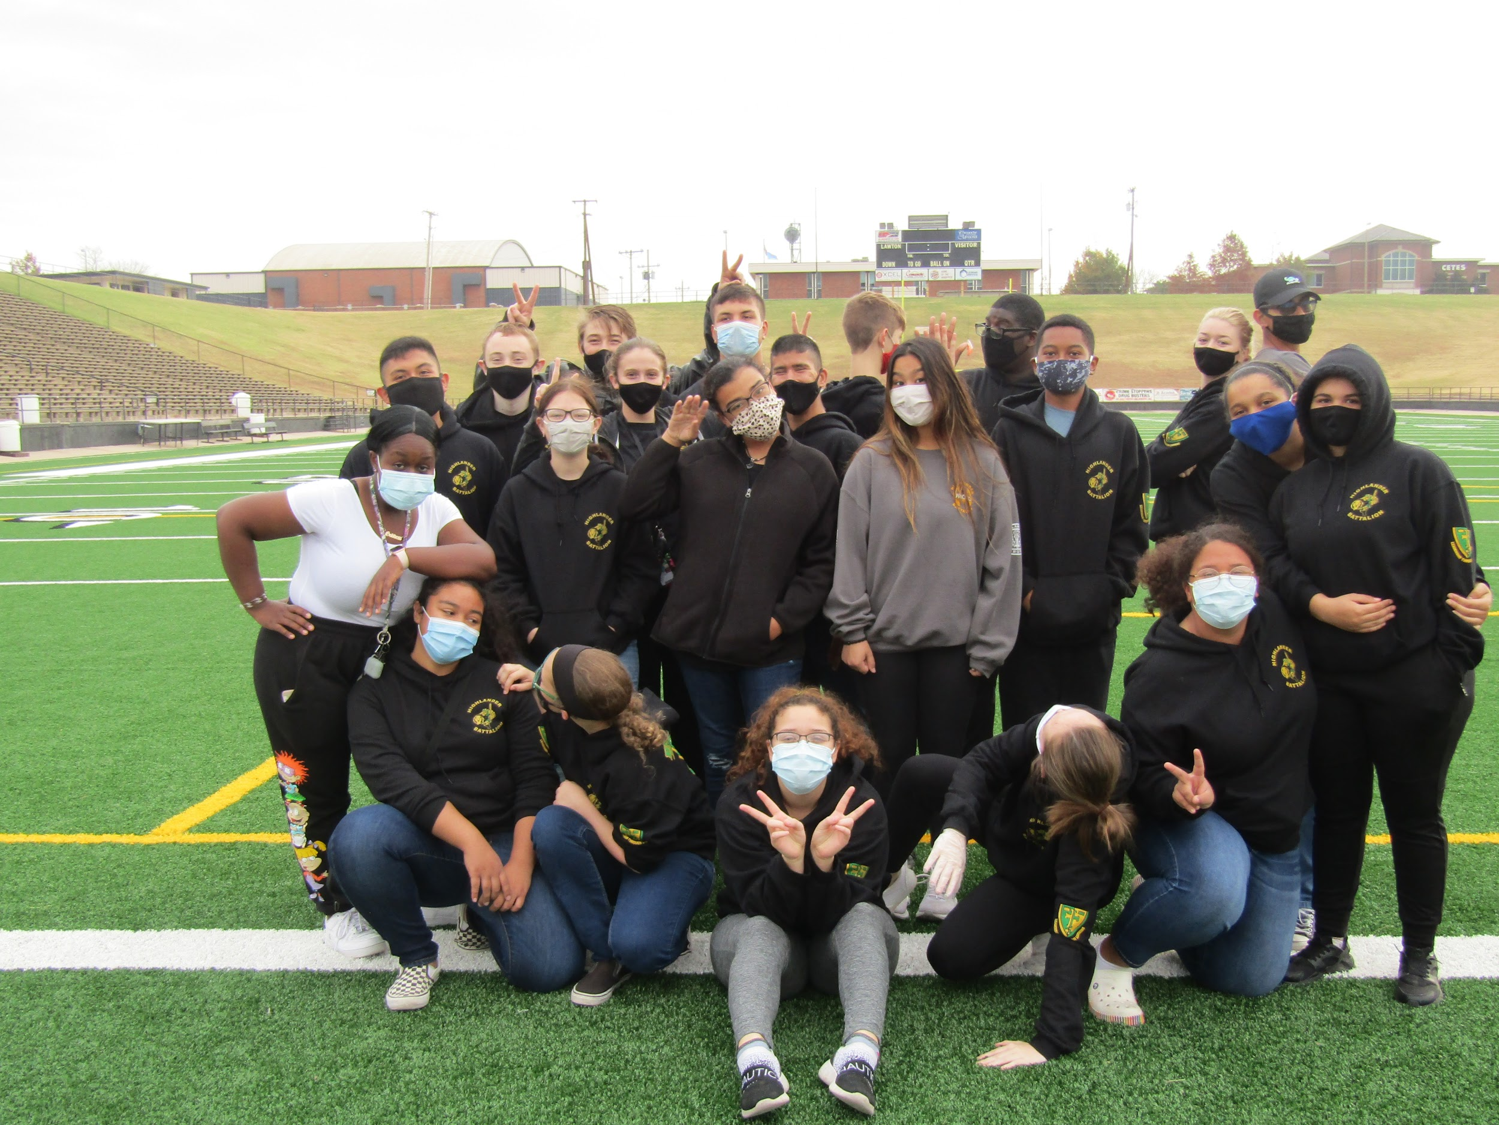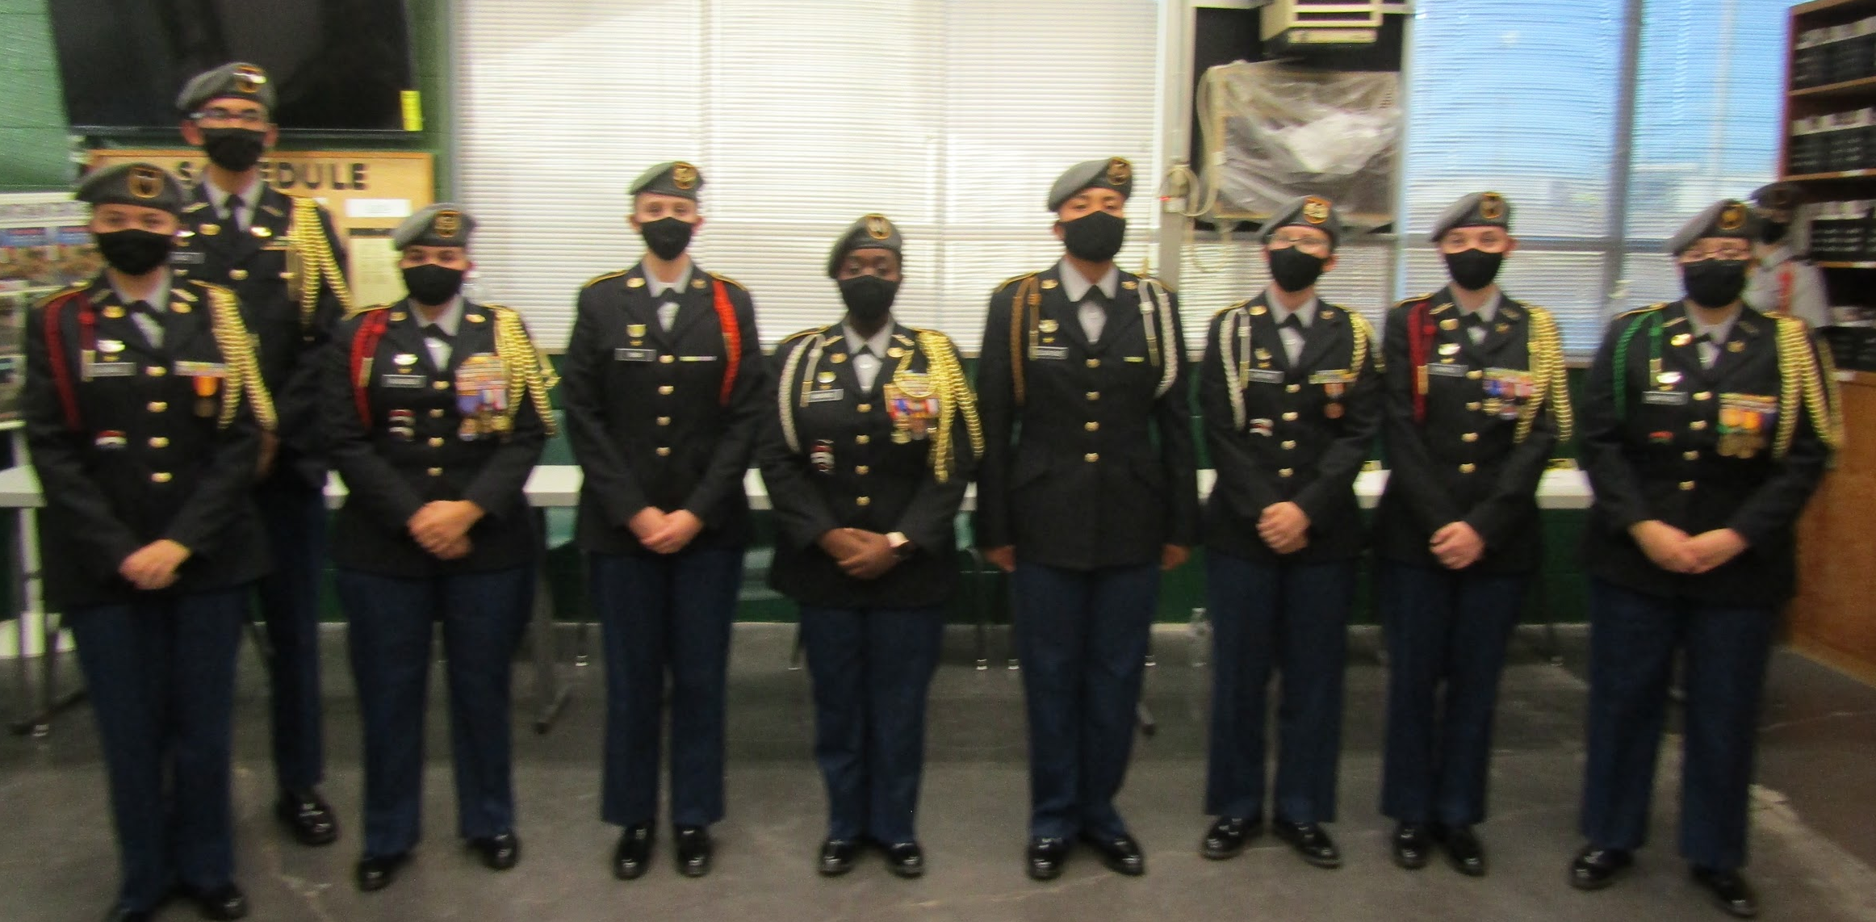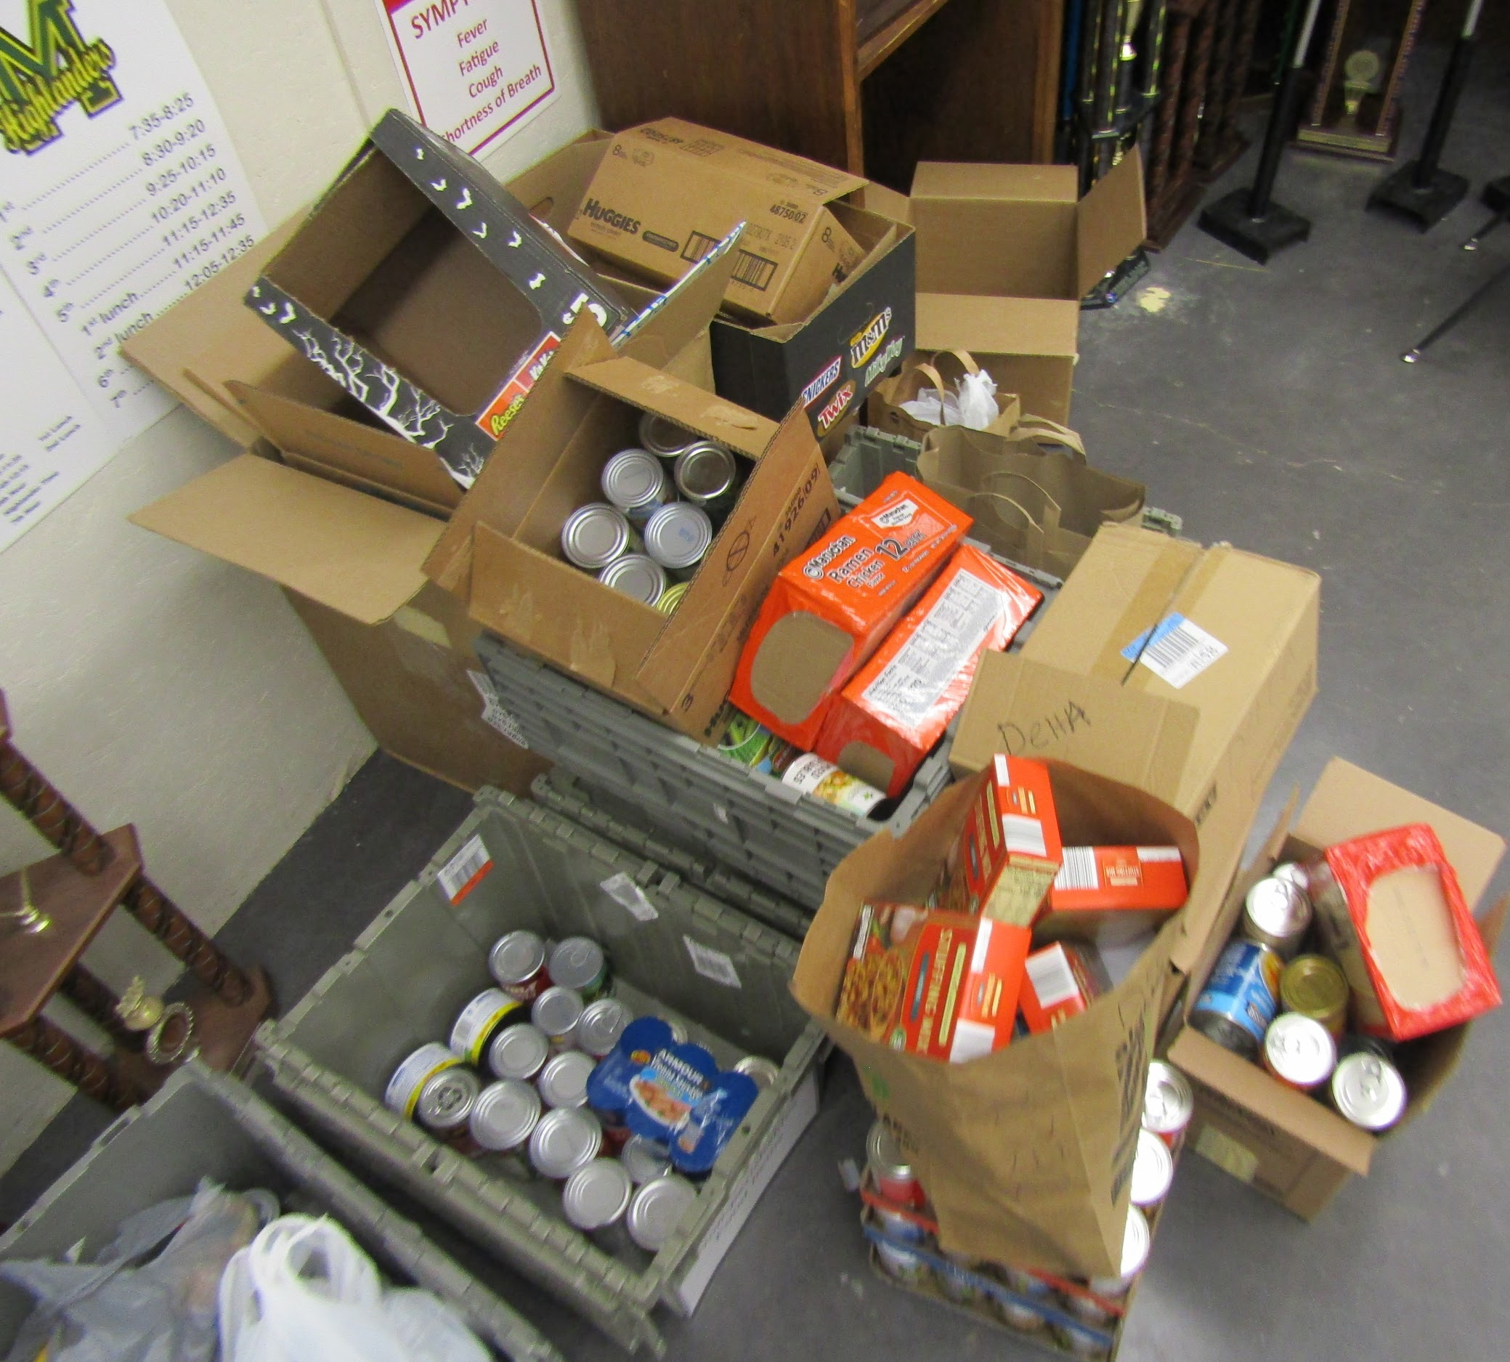
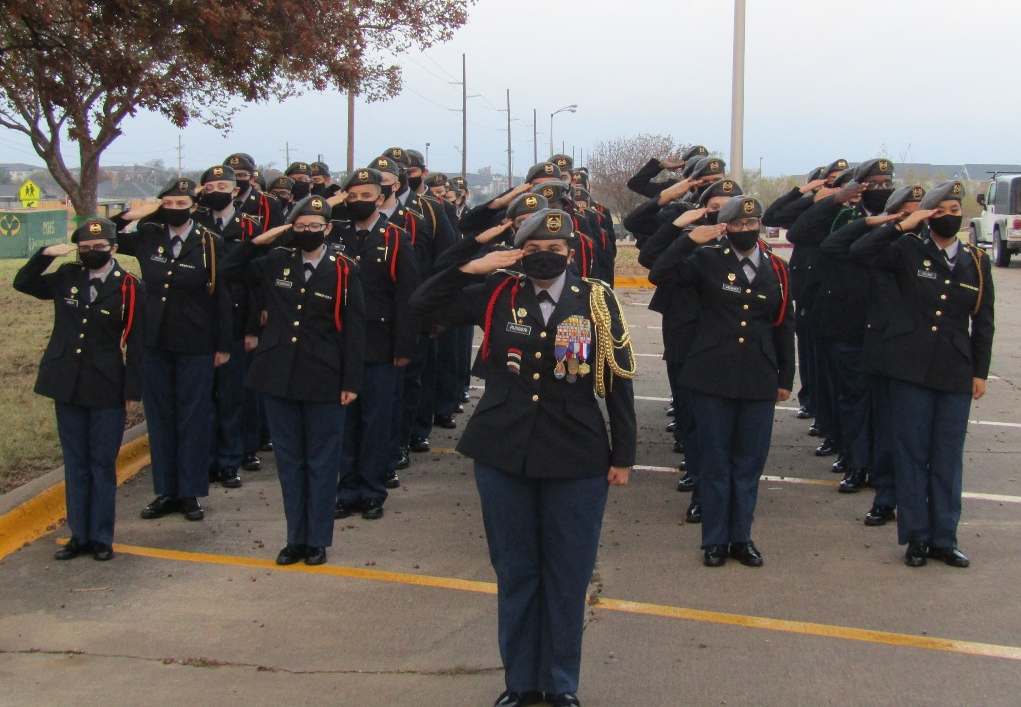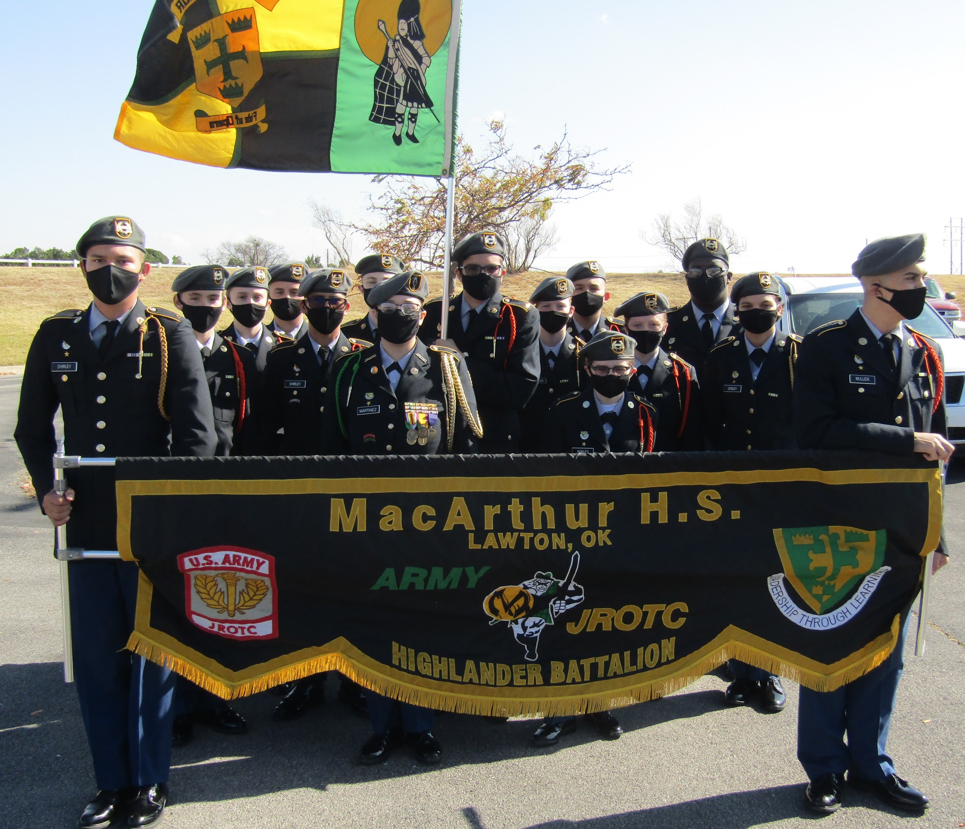
Cadet Highlights
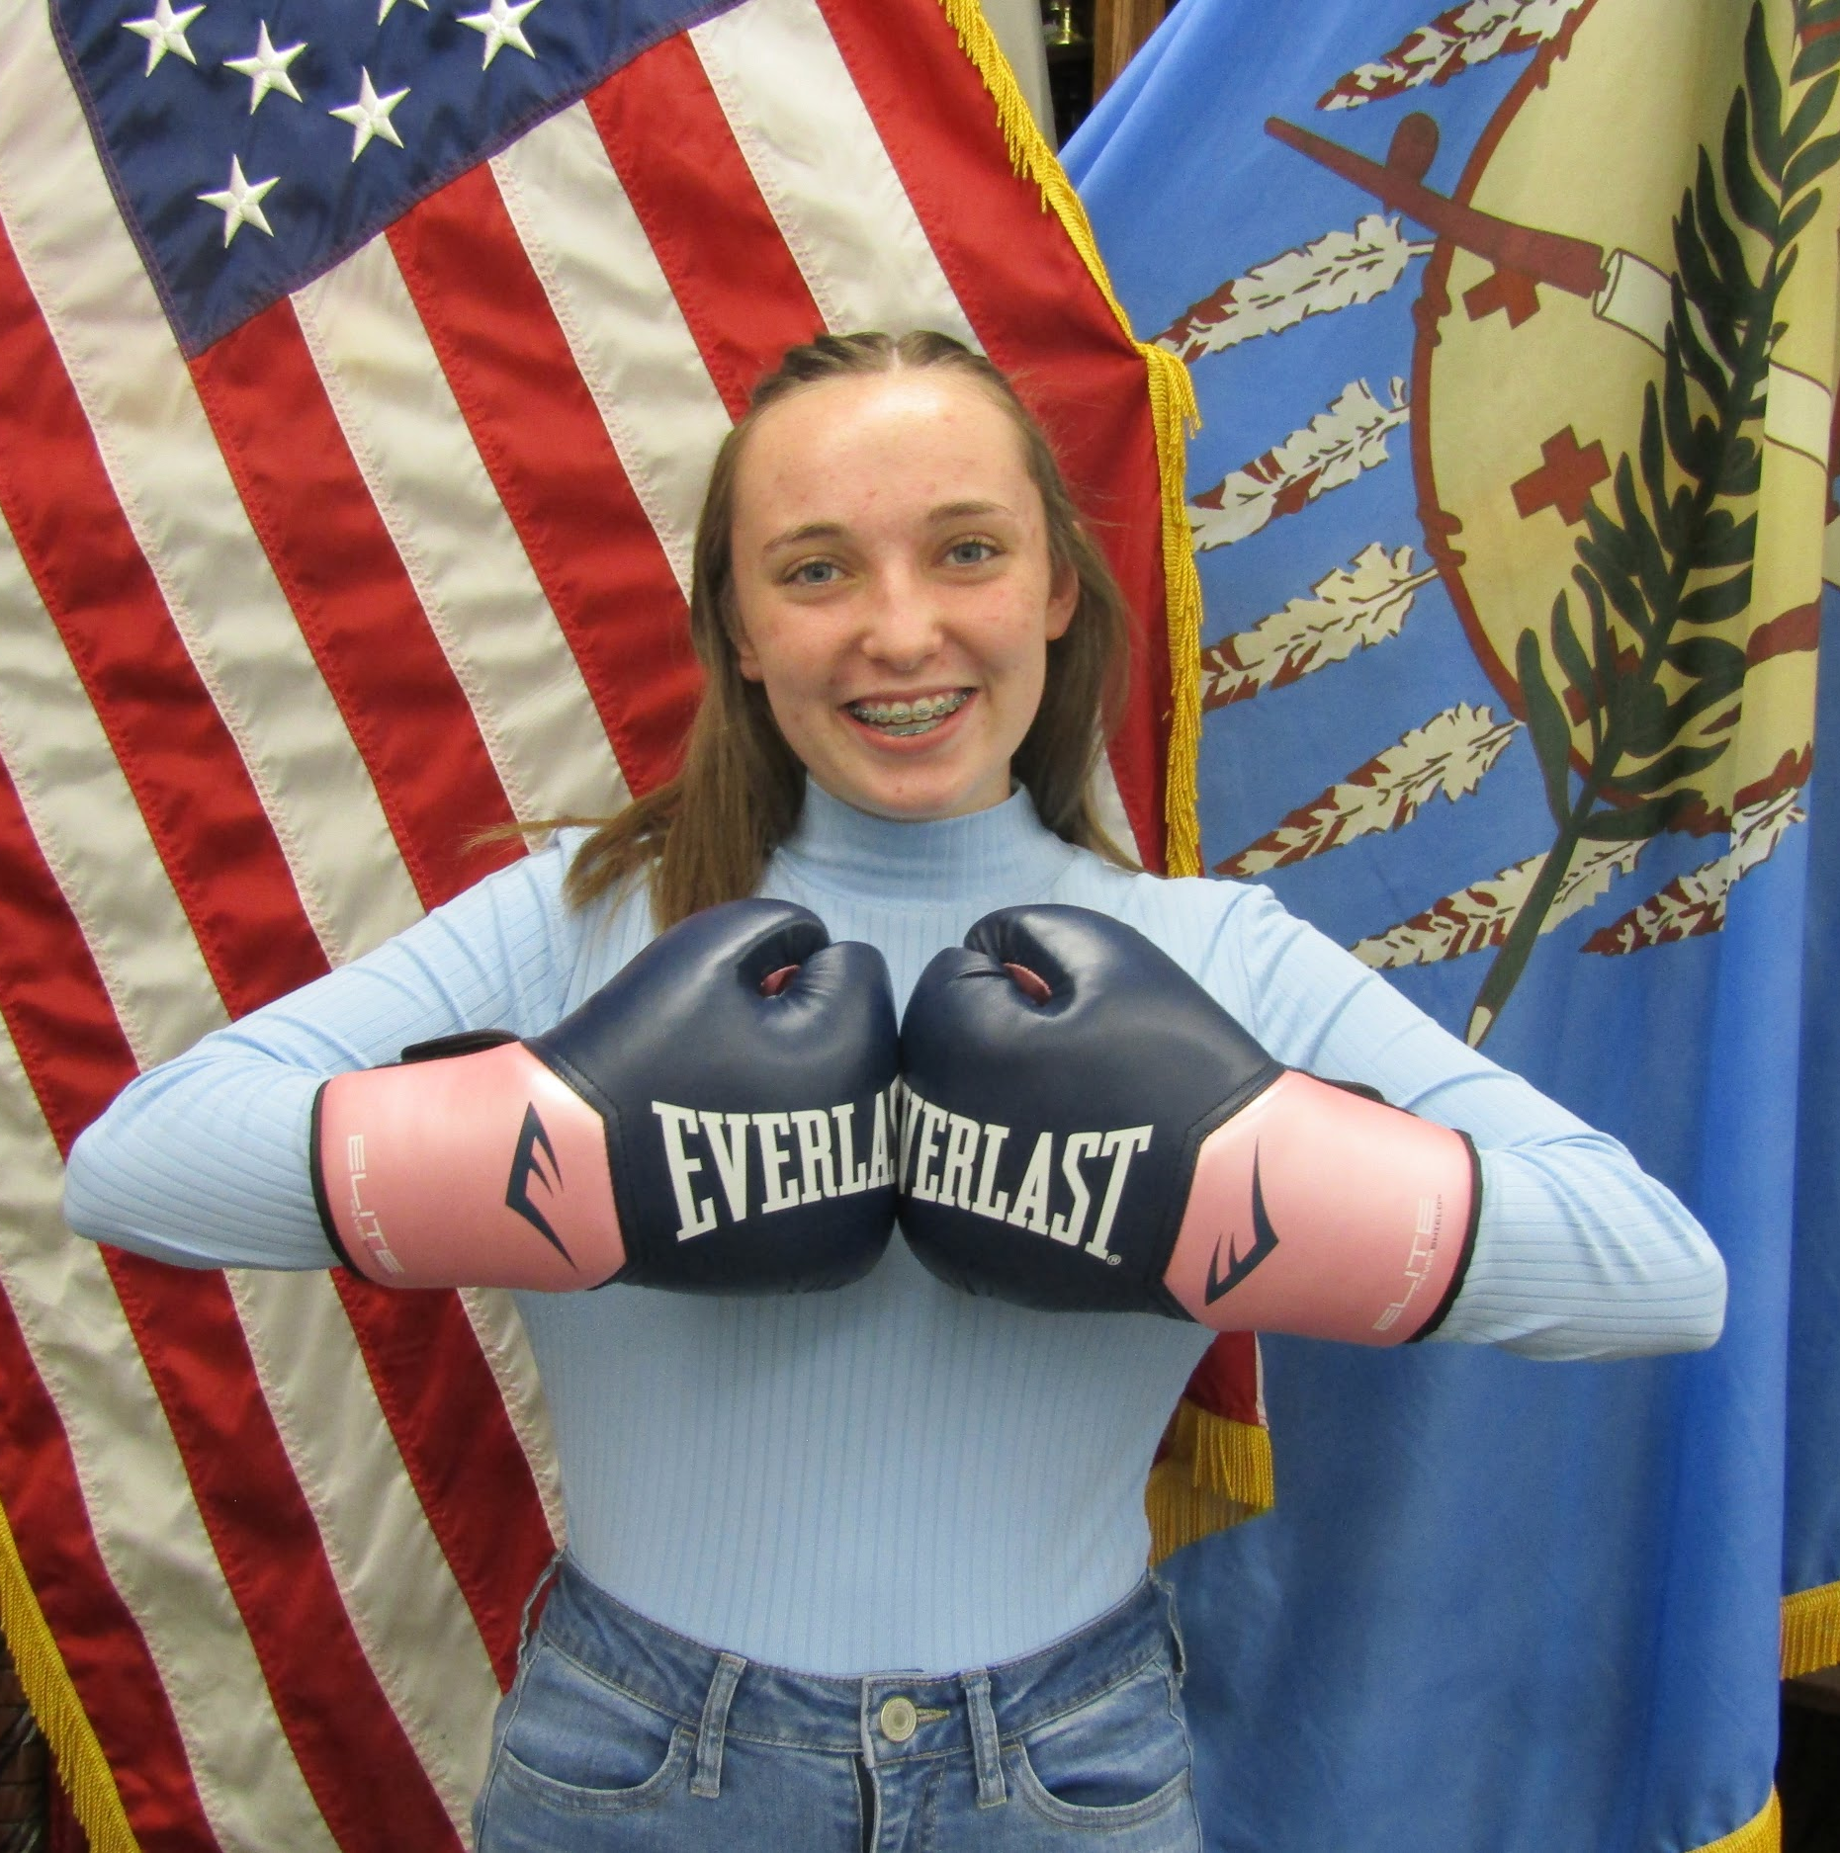
Cadet 1st Lieutenant Gracie Kimbrell is the S4 (Logistics Officer) of the Highlander Battalion. Cadet Kimbrell is a squad leader on the UnArmed Drill Team. She is also a member of a local boxing gym for the past two months. She is a Sophomore this year and a LET 2. She plans to continue working on her boxing skills and be involved in JROTC for the remainder of her high school career.
Cadet Sergeant John Kennedy is the Assistant S2 (Security NCO) of The Highlander Battalion. Cadet Kennedy is a member of the Armed Drill Team and Male Color Guard. He also has been training in karate and martial arts for the last three years. He is a Sophomore and LET 2. He plans to continue his training and be a part of JROTC for the remainder of his high school career.
What do you want for christmas ? Let us know to the right!

